.
WEEK 10
Week 10: Advanced SQL Query System Scenario: The e-commerce company wants to perform advanced analysis on customer purchases, product pricing, and sales performance. The management team needs complex reports to identify high-value customers, expensive products, and business trends. Students will implement Subqueries and Nested Queries to extract deeper insights from the E-Commerce Database.

Implement Subqueries and Nested Queries
- Single-row subquery
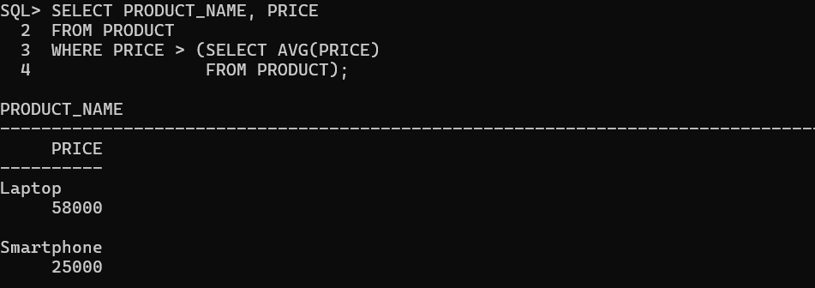
- Multi-row subquery
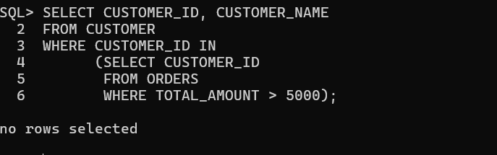
- Nested subquery
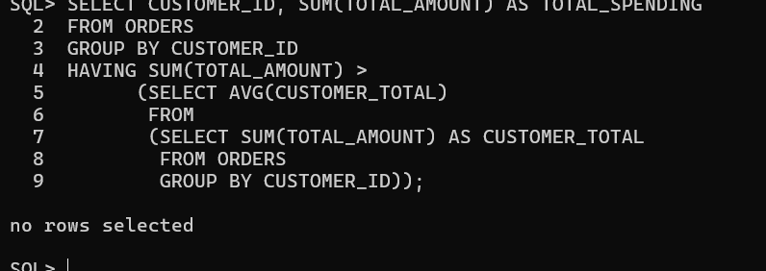
2. Find Products Above Average Price
Query 1: Find products priced above average
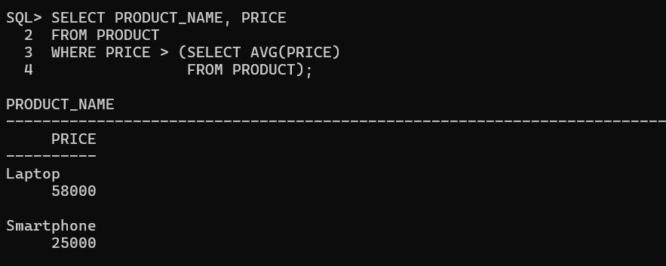
Query 2: Display product name, category and price
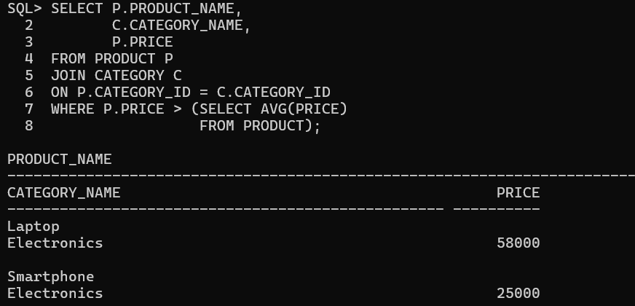

Query 3: Identify expensive products in each category
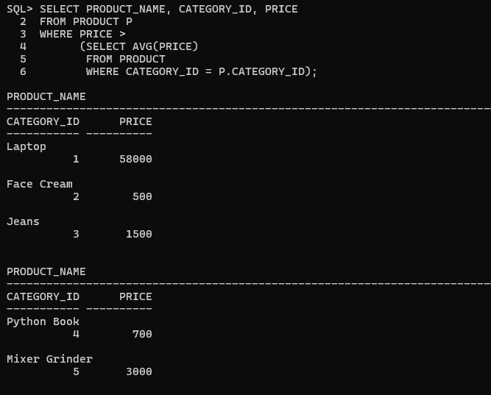

Query 4: Products with price higher than a selected category average

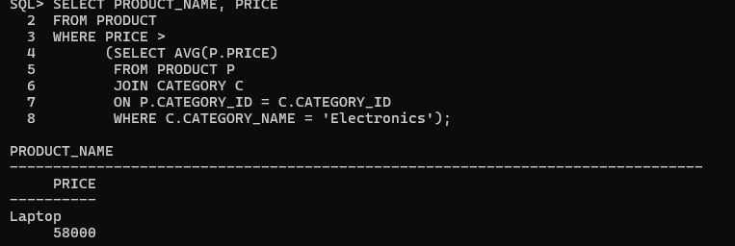

3. Identify Customers with Maximum Purchases

Query 1: Customer who spent the highest amount

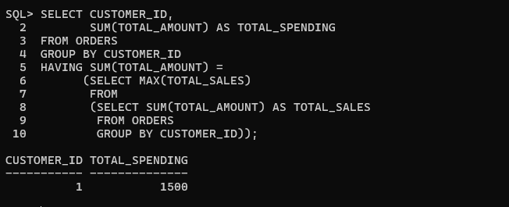

Query 2: Customers with maximum number of orders

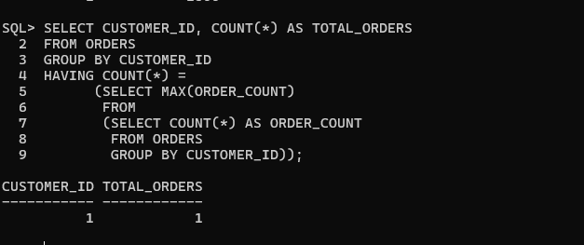

Query 3: Customers whose spending is above average

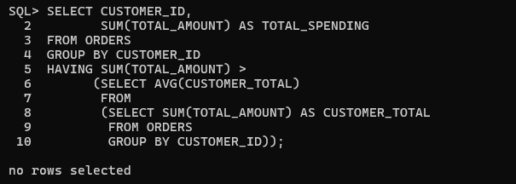

Top 5 Valuable Customers

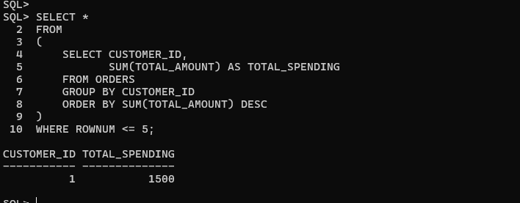

Query 3: Category Performance Analysis
- Highest revenue-generating category
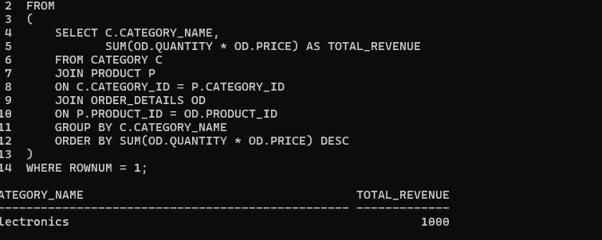
B. Category-wise revenue
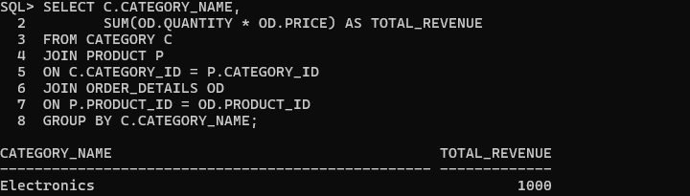

- Top-selling products

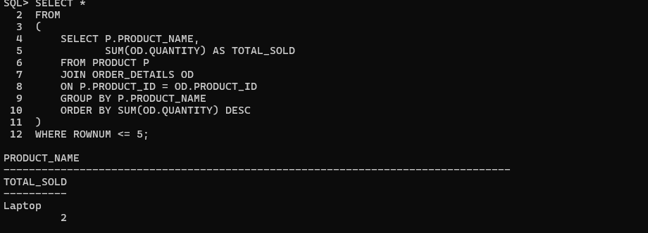

Report 4: Business Decision Report
A. High-performing products

B. Low-performing products

C. High-value customers



